**Easy Geo?**

**Input:** Standard Input, **Output:** Standard Output

**Time Limit:** 1 second(s)

**Memory Limit:** 256 megabytes

**Problem Statement:**

Let there is a 2D black wheel. The **difference** between **the circumference of outer side** of the wheel and **the circumference of inner side** of the wheel is **D** meter. The **ratio** of **the circumference of outer side** of the wheel and **the circumference of inner side** of the wheel is **K**. You have to find the **area** of that black wheel.

See the figure below for understanding the wheel.

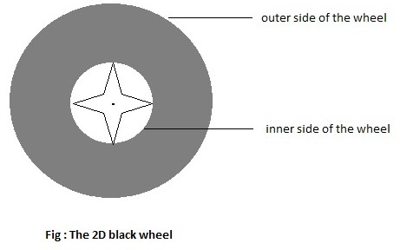

https://i.imgur.com/TXqwpFK.jpg

You have to find the **area** of that **black shaded portion** of the wheel.

**Input:**

The first line contains one integer **T (1 ≤ T ≤ 105)** — the number of test cases.

Each test case consists of two integers **D** and **K** where **(1 <= D <= 10^3 , 2 <= K <= 10^3)**

**Output:**

For each test case, print the **area** in a single line. Error less than **1e-6** will be ignored.

**Sample Input/Output:**

|  |  |
| --- | --- |
| **Sample Input** | **Sample Output** |
| 2  100 10  15 3 | 972.613541  35.809862 |